**CS 6384.OU1 Computer Vision**

**Project 1 Report**

**Summer 2014**

**By**

**Rahul Dhanendran**

**(rxd123230)**

**Project Description:**

This project consists of five programs that are related to the manipulation of color in digital images.

**Program 1:**

This program displays continuous changes in color for the xyY and Luv representations.

**Input:**

The input to the program is a width and a height.

**Output:**

The output is two images of dimensions width* height that are displayed on the screen.

**Pseudocode:**

1. Read the inputs.

2. For the xyY image, the pixel at row i and column j should have the color value:

x = j=width; y = i=height; Y = 1

3. For the Luv image, the pixel at row i and column j should have the color value:

L = 90; u = 512 _ j=width 􀀀 255; v = 512 _ i=height 􀀀 255

4. The obtained values are converted to sRGB representation by converting them to XYZ domain and then to sRGB domain.

5. The final values are clipped to stay within the range 0-255

6. The output images are displayed on the screen.

**Sample Input and Output:**

Width: 300 Height: 300

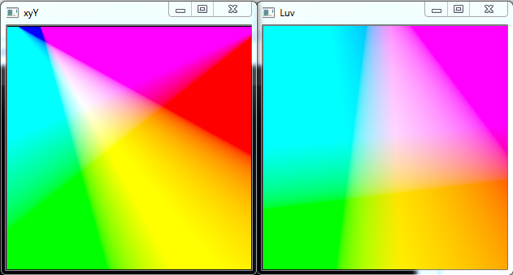

**Program 2:**

This program changes the color of the image based on a histogram computed from a window in the image. It performs scaling in the Luv domain by stretching only the Luminance values. The smallest L value in the specified window and all values below it are mapped to 0, and the largest L value in the specified window and all values above it are mapped to 100.

**Input:**

Width1, Height1, Width2, Height2, InputImage, OutputImage

**Output:**

Processed image.

**Pseudocode:**

1. Read input values.

2. Convert the sRGB image to Luv by converting it to XYZ and then to Luv.

2. Iterate over the specified window and calculate the smallest and largest L values.

3. Iterate over the entire image and map the L values accordingly to new L values.

4. Convert the Luv image back to XYZ and then to sRGB.

5. The final values are clipped to stay within the range 0-255.

6. Display the processed image.

**Sample Input and Output:**

Input: 0.9 0.0 1 0.1 fruits.jpg out.bmp

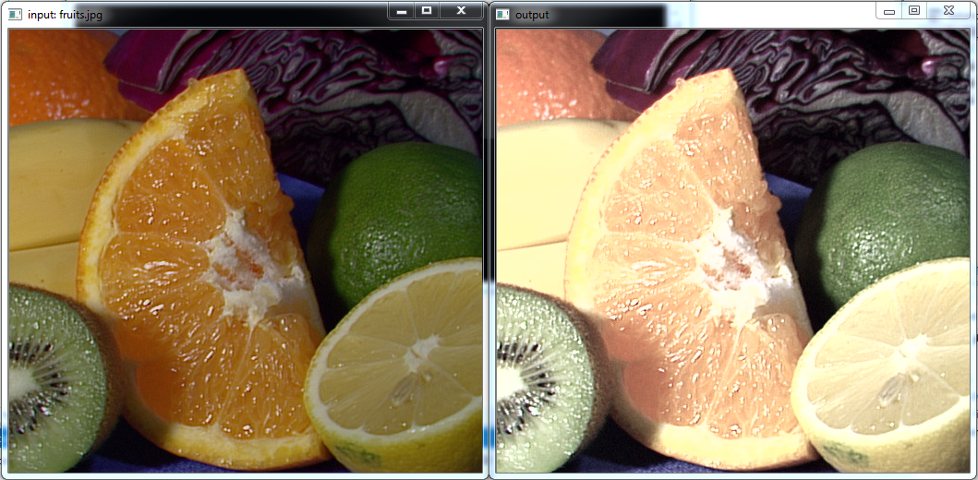

**Program 3:**

This program changes the color of the image based on a histogram computed from a window in the image. It performs histogram equalization in the Luv domain by discretizing only the Luminance values. The smallest L value in the specified window and all values below it are mapped to 0, and the largest L value in the specified window and all values above it are mapped to 100.

**Input:**

Width1, Height1, Width2, Height2, InputImage, OutputImage

**Output:**

Processed image.

**Pseudocode:**

1. Read input values.

2. Convert the sRGB image to Luv by converting it to XYZ and then to Luv.

3. Iterate over the specified window and calculate the smallest and largest L values.

4. Calculate the histogram equalization table for the window.

5. Iterate over the entire image and map the L values accordingly to new L values.

6. Convert the Luv image back to XYZ and then to sRGB.

7. The final values are clipped to stay within the range 0-255.

8. Display the processed image.

**Sample Input and Output:**

Input: 0.6 0.6 0.7 0.7 fruits.jpg out.bmp

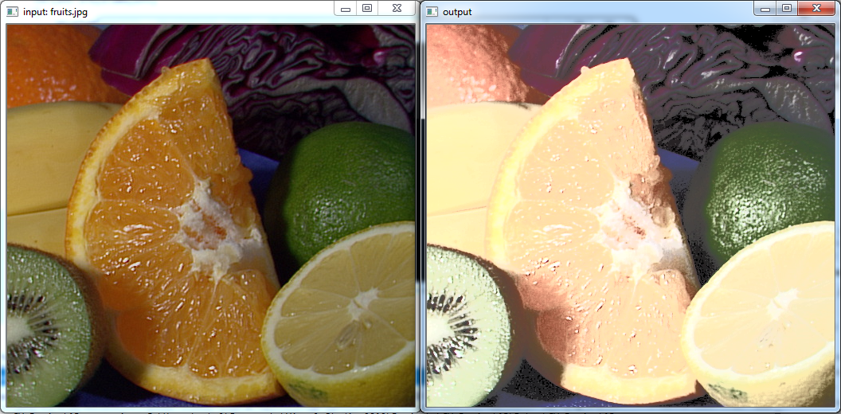

**Program 4:**

This program changes the color of the image based on a histogram computed from a window in the image. It performs scaling in the xyY domain by stretching only the Luminance values. The smallest Y value in the specified window and all values below it are mapped to 0, and the largest Y value in the specified window and all values above it are mapped to 1.

**Input:**

Width1, Height1, Width2, Height2, InputImage, OutputImage

**Output:**

Processed image.

**Pseudocode:**

1. Read input values.

2. Convert the sRGB image to xyY by converting it to XYZ and then to xyY.

2. Iterate over the specified window and calculate the smallest and largest Y values.

3. Iterate over the entire image and map the Y values accordingly to new Y values.

4. Convert the xyY image back to XYZ and then to sRGB.

5. The final values are clipped to stay within the range 0-255.

6. Display the processed image.

**Sample Input and Output:**

Input: 0.9 0.0 1 0.1 fruits.jpg out.bmp

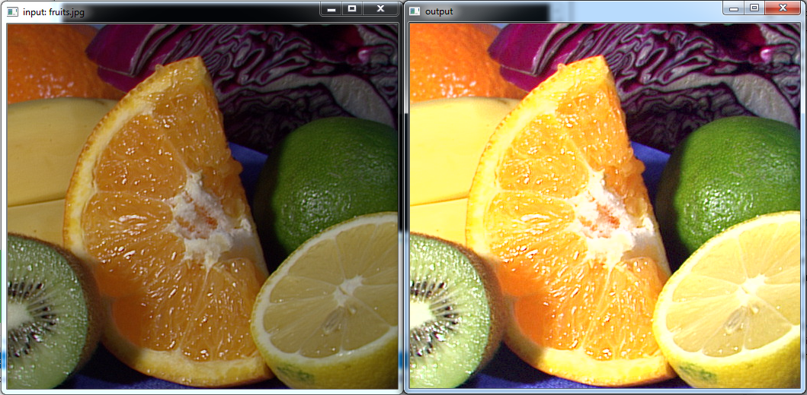

**Program 5:**

This program uses inbuilt OpenCV color conversion functions. It changes the color of the image based on a histogram computed from a window in the image. It performs scaling in the Luv domain by stretching only the Luminance values. The smallest L value in the specified window and all values below it are mapped to 0, and the largest L value in the specified window and all values above it are mapped to 100.

**Input:**

Width1, Height1, Width2, Height2, InputImage, OutputImage

**Output:**

Processed image.

**Pseudocode:**

1. Read input values.

2. Convert the sRGB image to Luv using cvtColor().

2. Iterate over the specified window and calculate the smallest and largest L values.

3. Iterate over the entire image and map the L values accordingly to new L values.

4. Convert the Luv image back to sRGB using cvtColor().

5. Display the processed image.

**Sample Input and Output:**

Input: 0.9 0.0 1 0.1 fruits.jpg out.bmp

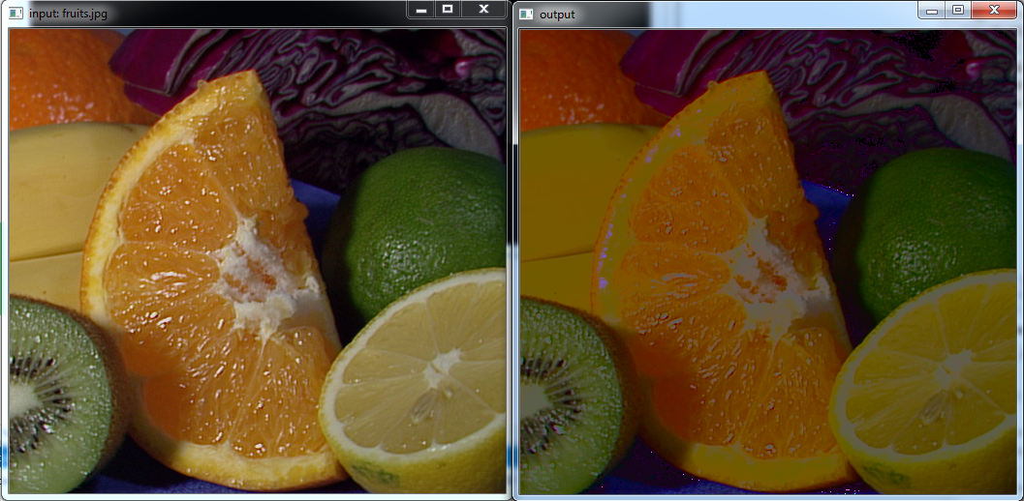

**Comparison:**

Programs 2-5 were run using the same input and the outputs are compared.

Input : 0.9 0.0 1 0.1 fruits.jpg out.bmp

